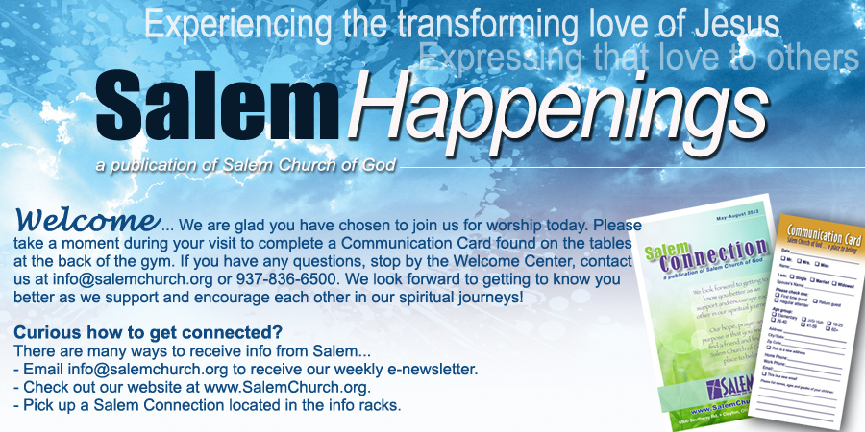

  August 3, 2012
  Community Table School Fair
  Sunday, Aug 12
  Volunteers Needed!
  The 6th annual Northmont Back to School Fair will be held Sunday August 12 and we need your help! We need volunteers to help set up Saturday morning Aug 11 at 10 a.m. at Happy Corner Church of the Brethren. We also need volunteers to help the children "shop" on Sun. Aug 12. There are two shifts 12:30- 3:30, or 3:30- 6:30 p.m. Sign-up sheets are located in the lobby outside the RAC. We are still collecting supplies. We are in desperate need of looseleaf notebook paper (standard and college ruled). Pick up complete list at the desk located by the gym. We are also in need of children's books and books for kids in grades 7-12. Place your donations in the bins beside the desk or in the Collection Center. Contact Debbie Stahl @ 832-8024 ortstahl1@woh.rr.com or Mary Wright @ 902-3656 ordforrestranger@msn.com
  Perkins Coupons Support Navajo Outreach Trip
  This Sunday, find an Arizona team member with a Perkins Fundraiser badge to get your Perkins coupon. These coupons can be used on Monday, August 6 at Perkins in Englewood. A portion of your meal cost will go towards this outreach trip. This team will assist Robin and Faith Jelle minister to the Navajos by installing windows, doors, and dry wall for the bunkhouse.
  The Prayer Wall Experience
  Prayer Wall -
  August 11 & 12, Englewood Fine Arts Festival, Centennial Park, Englewood
  Worship Service -
  Sunday, August 12,
  7:30 a.m., Centennial Park, Englewood
  On August 11 and 12, Salem will partner with Fairview Church in Englewood to bring the Prayer Wall Experience to the Englewood Fine Arts Festival held at Centennial Park. The Prayer Wall Experience is an outreach tool that leverages the common cultural understanding of prayer as a catalyst to communicate the love of Jesus in to the lives of those far from God. Volunteers are needed to serve as Wall Hosts during this two day event. There will also be a 7:30 worship service at Centennial Park on August 12. Contact Chris Hall at c.hall@salemchurch.org if you would like to serve as a wall host.
  Giving:
  Weekly Need: $34,815
  Offering 7/29/12:
  $22,778.42
  SalemChurch.org
  Click on "get connected" tab and scroll through the different areas. Listen online to teachings, submit a prayer request and more!
  Not A Sermon, Just A Thought
  From Pastor Moss
  "Next" is a word that builds anticipation. "What's next?" is a question we all frequently hear.
  Sometimes focusing on what's next presupposes dissatisfaction or discontent with a current situation. Other times, our habitual quest of the next thing causes us not to enjoy our present situation. Like most other things, the anticipation of what's next can be healthy or unhealthy depending upon your underlying motivation.
  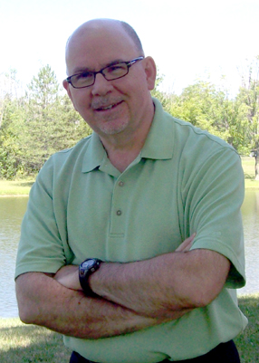
  Salem Church is ready for the next phase of our life as a congregation. Momentum has been building throughout the summer months and we are all looking forward to moving back into our main auditorium on Sunday September 9.
  I'm anticipating that you will be thrilled by the new look and the new sound in our worship center. The clarity of the new sound system is amazing. The lighting and video equipment have experienced major upgrades. You'll be pleased.
  We're looking forward to the next stage of growth in our outreach; the next stage of growth in our small group ministry. We're literally preparing for and expecting the next wave of growth at Salem!
  How can you help? I'm glad you asked. Help us prepare for the next great day of celebration as we move into our renovated auditorium on September 9. We need our entire church family to be present to help us celebrate! It's going to be a fantastic day!
  Consider attending BOTH services at 9:30 and 11 a.m. to help us express hospitality and welcome our guests. I'm asking some Sunday school classes to discuss a shift from meeting at 9:30 to 11:00 a.m. in order to balance worship attendance and to provide us with more hosts on that Sunday.
  Are you ready for what's next?
  Enthusiastically,
  Pastor Moss
  
  VBS Registration
  VBS 2012, August 6 -10, (Monday-Friday), 9 a.m. – noon-VBS is just around the corner where kids and adults will get to meet Daniel and learn about this new culture from his perspective. Please register online at SalemChurch.org. Contact Craig at ext. 112.
  VBS Donations and Volunteers Needed
  VBS is almost here!! We are in need of these items: fruit snacks, pop ice (popsicles), and juice boxes. Please drop your items off in the Collection Center bins (across from the outreach map). Volunteers are also needed (teenagers welcome!). Register online at SalemChurch.org
  Discipleship Mentoring
  Which of these describes you: You show up at church every Sunday, or you are a real disciple of Christ? There's a big difference! Consider becoming a disciple of Christ. You'll (a) learn what Christ taught, (b) understand those teachings with the help of a personal mentor so you can internalize those teachings, and (c) learn how to lead others to follow Christ as well. Contact Sylvia Miller at sylviaamiller@woh.rr.com or at 937-671-5267 for details.
  Royal Rangers
  The Royal Rangers are looking for a few additional men to serve as leaders and support. This fall begins the sixth year for Royal Rangers at Salem and it is a growing ministry. Growth in this excellent ministry area can continue with your support. For more information, contact Jeff Webb at webbsalemranger@aol.com.
  Church of God Ohio Central District
  107th Camp Meeting
  August 3-12, 2012, 3251 West National Rd., Springfield, OH 45504, 937-322-9600
  "Staying on the Front Lines." Guest Speaker: Luz Gonzales, Music Minister: Mick Gilliam
  For more information, check out www.springfieldcampmeeting.org.
  Baptism
  Baptism Preparation Class, August 12, 9:30 a.m., Room 209
  Baptisms, August 26, 11:00 a.m. Worship Service
  Baptism by immersion is a first step for the new believer. If you would like to be baptized or have any questions regarding the purpose or meaning of baptism please contact 937-836-6500 or info@salemchurch.org.
  Pastor Bob Moss to Speak at the
  2012 Ohio Men's Retreat & Ox Roast
  September 7 & 8, Camp Marengo, Columbus, Ohio
  Men, let's join Pastor Bob at this retreat and show him our support and love. The theme this year is "Be Strong & Courageous." Mark this date on your calendar and let's send an army of men over to Camp Marengo. Early bird registration is $50 through August 15, $60 after that (children 12 and under is $25). This covers lodging, a Friday night dinner, a Saturday morning breakfast followed by a pig roast Saturday at noon to complete the weekend. There is a golf tournament, fishing tournament, and paintball for a fee. Cornhole and horseshoes are free. Register online atwww.ohchog.org/men or registration forms are available on Sundays in the lobby. Contact Craig atmensministry@salemchurch.org or ext. 112 for questions.
  Spiritual Formation Series and Retreat
  "God is Out for Your Good!"
  Retreat September 8, 9 a.m. - 3 p.m., Classes begin September 17, 7-8:30 p.m.
  Apprentice Series (The Good and Beautiful God/Life/Community). Sign-up begins August 5 at the Ministry Center. Contact David and Marilyn McQuinn at 937-836-7800.
  First Impressions Ministry Team
  One of the most important things we do at Salem is provide a warm welcome and a friendly smile to our guests. First Impressions team members help create a hospitable environment that welcomes all people to the Salem campus so that they feel like they belong and will understand how to connect with the facility, people and the programs offered. Would you like to join the team? If so, contact Alisa at ext. 123.
  Salem Trailblazers Luncheon Outing
  Thursday, August 9, 12 p.m., Rob's Restaurant, Brookville, OH
  The Salem Trailblazers are a group of mostly retired folks, 55 and older. We invite you to join us for our next lunch outing. Please note the change of venue. We will meet at Rob's Restaurant in Brookville. Contact Herm at 832-6348 for info.

Salem Church of God / 6500 Southway Rd. / Clayton, OH 45315 / 937-836-6500 / www.SalemChurch.org
If you have a medical emergency and need to contact a staff person after office hours please call 937-474-9753.

